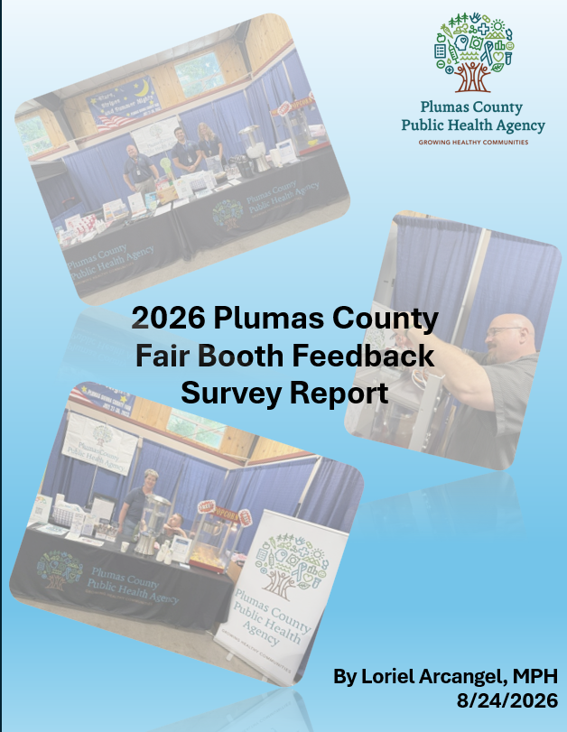

Table of Contents
Executive Summary 3
Booth Feedback Survey Information 3
Overall Appearance Rating 6
Rating Information Provided 7
Staff Interaction with the Public 8
Additional Comments 9
Types of Feedback 9
Types of Praise 10
Types of Areas of Improvement/Personal Opinion 11
Other Areas of Improvement Regarding Information Sharing 12
Limitations 12
Fair Booth Photos Throughout the Years 13
2026 13
2025 14
2024 15
Appendix 1: Participant Written Comments by Theme 16
Praise on Fair Booth 16
Areas of Improvement 17
Information Sharing 18
No Improvement Needed 18
Other 18

Executive Summary
In July 2026, at the annual Plumas County-Sierra Fair participants were asked to complete a survey regarding PCPHA’s booth. The survey asked how the participants would rate the overall appearance of the booth, how useful the information from the booth was, and the staff’s interaction with the public. Participants would rate each of these categories as either unacceptable, poor, average, good, and excellent. Since a similar survey was done in 2024 and 2025, the results of the 2026 survey were compared with 2024 and 2025. Using an exact binomial test to compare the percentage of people who answered excellent for the three categories mentioned previously, the test suggested that all years except one year shared similar results for overall appearance of the booth, how useful the information from the booth was, and the staff’s interaction with the public. The only year that had a statistical difference with 2026 was 2024 in rating of staff interaction with the public. This difference suggested that staff interaction had improved in 2026 in comparison to 2024. The survey also gave participants an option to write down additional comments about the booth and ways that the booth can improve in the future. The themes generated from the additional comments were praises for the booth, areas of improvement/personal opinion, information sharing, no improvements needed, and other. Most comments gave praise to the fair booth, but other comments suggested areas of improvement such as having a bigger and clearer sign of services sharing pictures, graphics, and explanation of those services in the backdrop of the booth.

Booth Feedback Survey Information
In the survey, participants would rate the booth’s appearance, information, and staff interaction as either unacceptable, poor, average, good, and excellent. There were 93 participants. Of the 93 participants, 15 submitted the survey electronically (16%), and 78 submitted paper surveys (84%). From the survey, 61 out of the 93 participants gave additional comments (66%).
In 2024 and 2025, the same survey regarding PCPHA’s booth was given to those who attended the annual fair. In 2024, there were 65 participants. Of the 65 participants, 52 submitted electronic surveys (80%), and 13 submitted paper surveys (20%). Only one participant did not answer about the overall appearance of the booth. From the survey, 24 out of the 65 participants (37%) gave additional comments. In 2025, there were 58 participants, but only 57 participants were used in the assessment since there was one participant who gave conflicting information in their survey responses. Of the 57 participants, 23 submitted electronic surveys (40%), and 34 submitted paper surveys (60%). From the survey, 34 out of the 57 participants gave additional comments (60%).
To compare the Plumas County Fair Booth’s feedback responses for the last three years, the number of people who gave a certain rating over the total number of participants for a given year was used. This proportion was shown for each of the years as a percentage. To test if the difference between feedback responses were different in 2026 than in 2024 or 2025, the one-tailed hypothesis exact binomial test was conducted. Percentages of how many participants chose excellent for overall appearance, information provided, and staff interaction in 2026 were compared with the percentages of participants who chose excellent for these three categories in 2024 and 2025. The direction of the one-tailed hypothesis was based on whether the percentage of people in 2026 who chose excellent for each category was lower or higher than in 2024 or 2025. If the p-value for the test was less than 0.05, the difference between 2026 and the comparison year would be statistically significant, which suggests that the fair booth had improved or needs more improvement in 2026 than the comparison year.
To analyze the open-ended written responses from participants who answered the 2026 survey, a thematic analysis was conducted by grouping together comments that share similar suggestions or thoughts of the fair booth and generating themes from the groups created. Table 1 shows the themes generated and their definitions, and appendix 1 shows all the comments that survey participants had written in the survey with each comment sorted by themes in Table 1. A comparison of additional comments between 2026, 2025, and 2024 was not done due to the variability of comment themes between the three years.

Table 1. Themes of Additional comments
Themes | Definitions
Praise on fair booth | People commenting on how impressed they were with the implementation of the fair booth
Areas of Improvement/Personal Opinion | People commenting on what they wished the Fair Booth would do or have
Information Sharing | People commenting how the fair booth should share information and what should be shared
No Improvement Needed | People commenting that they do not see any improvement needed at this time
Other | People's comments that do not fit with the four other categories, specifically on people whose writing could not be deciphered or who wrote a question mark in the question "How can we improve?"
Specific Categories on Areas of Improvement/Personal Opinion | Definitions
Merchandise/Food Request | People commenting on items that they would like the Fair Booth to give
Program Request | People commenting on what programs they would like to show up in the Fair Booth
Improvements for Fair Booth | People commenting on the amenities that the fair booth should have
Types of Praise | Definitions
General Praise | Non-specific praise on overall implementation of the fair booth
Appreciation of Food/Items | Praise specifically on the food or items given at the fair booth
Fair Booth Acknowledgement | Praise specifically on the look, info, or organization of the fair booth
Staff Acknowledgment | Praise specifically on the staff's interaction and conduct with the public in the fair booth

Overall Appearance Rating
Graph 1. Overall Appearance of the Fair Booth Rating 2024, 2025, & 2026

Out of the 93 participants that answered the 2026 Plumas County Fair Booth Feedback Survey, 83 (89%) of the participants rated the appearance of the booth as excellent. Nine (10%) of the participants rated the appearance as good, and one (1%) of the participants reported that the booth’s appearance was average. The graph above compares the fair booth feedback responses of 2024, 2025, and 2026.
When comparing 2026 feedback with the last two years, 2026 (89%) had a higher percentage of people rating the overall appearance as excellent than 2024 (83%) but a lower percentage of people giving an excellent rating in 2025 (91%). Based on the exact binomial test that determines whether this difference is statistically significant, 2026’s comparisons with both years were not statistically significant. The difference in percentages between the three years may be due to the difference in the number of people who answered the survey in those years. Overall, the percentage of people who gave an excellent rating in 2026 is high regarding the overall appearance of the booth and suggests similar results in comparison to the last two years.

Rating Information Provided
Graph 2. Information & Handouts Provided at the Fair Booth Rating 2024, 2025, & 2026

Out of the 93 participants that answered the 2026 Plumas County Fair Booth Feedback Survey, 82 (88%) of the participants rated the information provided in the booth as excellent. Ten (11%) of the participants thought the information was good in terms of its usefulness, and one (1%) of the participants responded that the information was average in terms of its usefulness. The graph above compares the fair booth feedback responses of 2024, 2025, and 2026.
When comparing 2026 feedback with the last two years, 2026 (88%) had a higher percentage of people rating the information provided as excellent than 2024 (83%) and 2025 (86%). Based on the exact binomial test that determines whether this difference is statistically significant, 2026’s comparisons with both years were not statistically significant. The difference in percentages between the three years may be due to the difference in the number of people who answered the survey in those years. Overall, the percentage of people who gave an excellent rating in 2026 is high according to the information provided at the booth and suggests similar results to the last two years.

Staff Interaction with the Public
Graph 3. Staff Interaction with the Public Rating 2024, 2025, & 2026

Out of the 93 participants that answered the 2026 Plumas County Fair Booth Feedback Survey, 90 (97%) of the participants rated the staff’s interaction with public as excellent. Two (2%) of the participants thought the staff’s interaction with the public was good, and one (1%) of the participants responded that the staff’s interaction with the public was average. The graph above compares the fair booth feedback responses of 2024, 2025, and 2026.
When comparing 2026 feedback with the last two years, 2026 (97%) had a higher percentage of people rating staff’s interaction with the public as excellent than 2024 (88%) but slightly lower in 2025 (98%). The fair booth in 2025 was the only year that no participant in the survey rated staff interaction as average. Based on the exact binomial test that determines whether this difference is statistically significant, 2026’s comparison with 2025 was not statistically significant; however, 2026’s comparison with 2024 was statistically significant. The statistical difference between 2024’s responses and 2026’s responses suggests significant improvement of staff’s interaction with the public from 2024 to 2026. Even though 2025 did not have anyone rate the staff interaction as average unlike 2026, the difference in percentages between 2025 and 2026 may be due to the difference in the number of people who answered the survey in those years, which means that the difference between the two years should be interpreted with discretion. This may also be true between 2024 and 2026, but the higher number of participants for 2026 (93 participants) in comparison to 2024 (65 participants) makes this possibility less likely. Overall, the percentage of people who gave an excellent rating in 2026 is high regarding staff’s interaction with the public, suggests similar results to 2025, and suggests significant improvement when compared to 2024 results.

Additional Comments

Types of Feedback
Graph 4. Themes of Additional Comments for the Public Health Fair Booth 2026

Out of the 93 participants who answered the survey, 61 participants (66%) provided additional feedback or gave written comments on ways to improve the public health fair booth. Around 45% of the participants who answered the survey gave positive feedback regarding the implementation of the fair booth. Around 13% of the participants who answered the survey wrote comments detailing areas of improvement or personal opinion on what public health could do in the next fair booth, and around 8% of the participants who answered the survey wrote comments providing ways that public health could share information with the public during the fair booth and what should be shared. About 4% of participants stated that no improvement was needed for the fair booth, and 3% of participants had comments that were categorized as “other.” Comments that were categorized as "other" were written comments that were illegible for review or were question marks.

Types of Praise
Graph 5. Specific Themes of Praise for the Public Health Fair Booth 2026

Out of the 42 participants that wrote positive feedback about the fair booth in the survey, around 43% of those participants wrote that the fair booth did well overall without providing any specifics. Around 31% of those participants wrote positively about the staff working at the booth such as how friendly and engaging the staff was, how helpful they were in sharing information regarding public health and their programs, and how hardworking the staff was during the event. Around 21% of the 42 participants that provided positive comments about the fair booth shared their appreciation of the food and items given at the fair booth. These items include popcorn, naloxone and beverage testers, cold water, and toothbrush. Around 19% praised the look of the fair booth, how organized the fair booth was, and the information provided.

Types of Areas of Improvement/Personal Opinion
Graph 6. Specific Themes of Areas of Improvement/Personal Opinion for the Public Health Fair Booth 2026

Out of the 12 participants who wrote comments about areas of improvement or their opinion on what public health can do for the next public health fair, 58% of them requested new food or merchandise to give to the public. Items suggested were cotton candy, more popcorn, beans, cute colorful plushies for kids, chocolate, lemons or cucumbers in water, and purse size hand sanitizers. Around 33% of these participants requested that public health provide certain amenities for the fair booth such as playing music at the booth, having a clipboard for answering surveys, or having a working popcorn machine. People commenting for public health to have a working popcorn machine may have been due to the current popcorn machine for the 2026 fair booth having a short malfunction at one point during the fair. Around 8% of the participants requested a program to be present in the fair booth, specifically having the harm reduction program present with their harm reduction van.

Other Areas of Improvement Regarding Information Sharing
Besides requesting clipboards for answering survey questions, having music in the background in the fair booth, and using a new popcorn machine to prevent sudden malfunctions during the fair booth event, participants also provide other suggestions of improvement to better help disseminate public health information during the fair booth. Participants suggested that the fair booth should have a bigger and clearer sign with explanations of services, pictures, and graphics in the backdrop behind the booth. Others suggested having a video showing in the fair booth, having a website sharing healthy events happening in Plumas County, conducting more publicity about public health events for the community, and sharing information about current health risks in the area.

Limitations
One limitation in this report is the varying number of survey participants in 2024, 2025, and 2026. The difference in total number of survey participants in each year may be an underlying factor in the difference in responses between the three years. This difference may cause comparing the different years to be imprecise, which is why comparing the three years should be viewed with discretion. However, despite each year’s different total number of survey participants, each year’s sample size should give an estimate of the true value of the public’s ratings of the fair booth for each year, allowing their percentages to be comparable with one another.

Fair Booth Photos Throughout the Years

2026
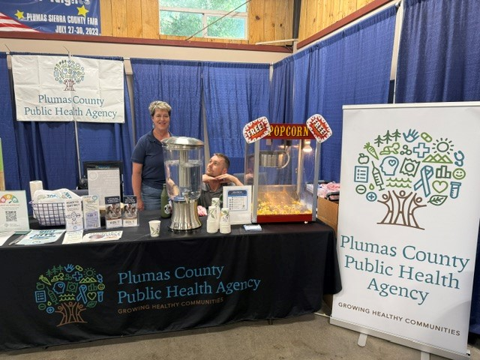
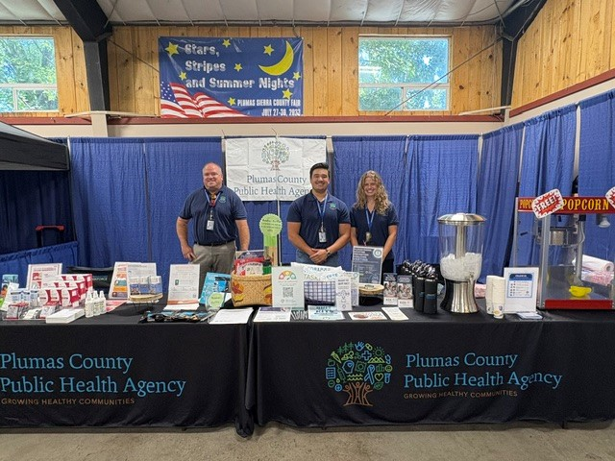
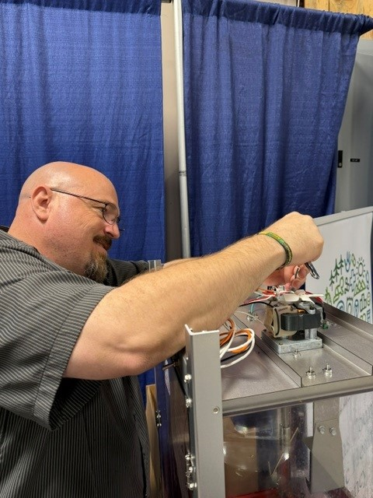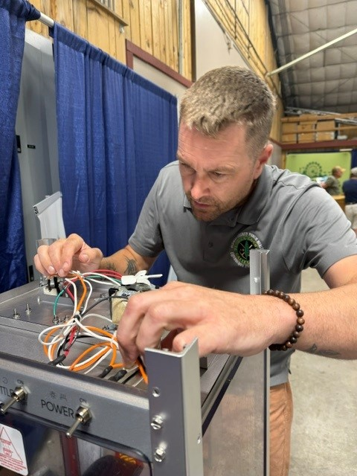

2025
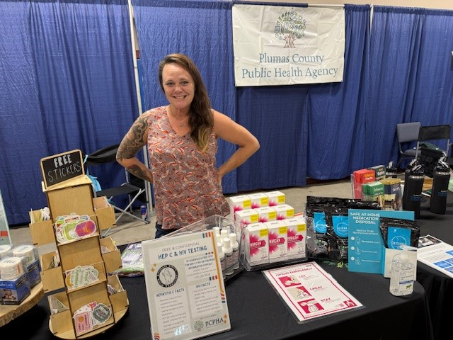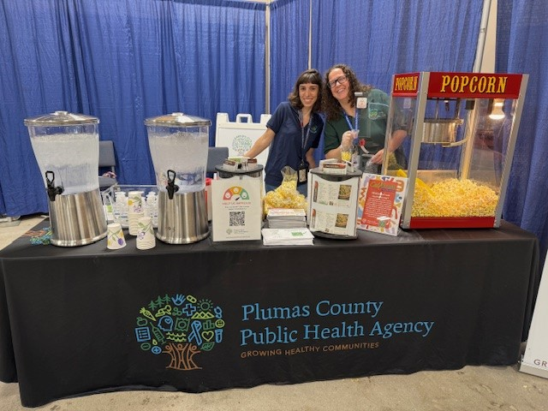
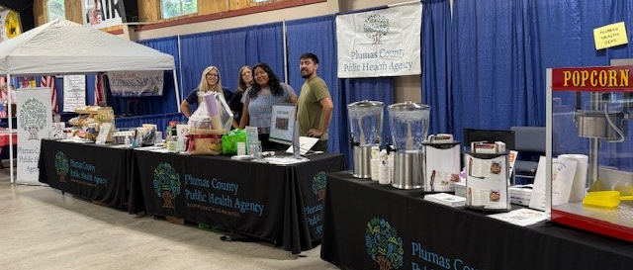
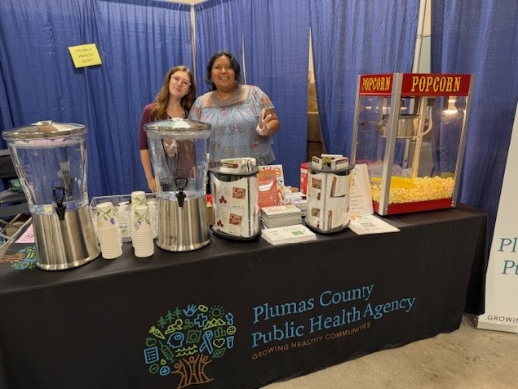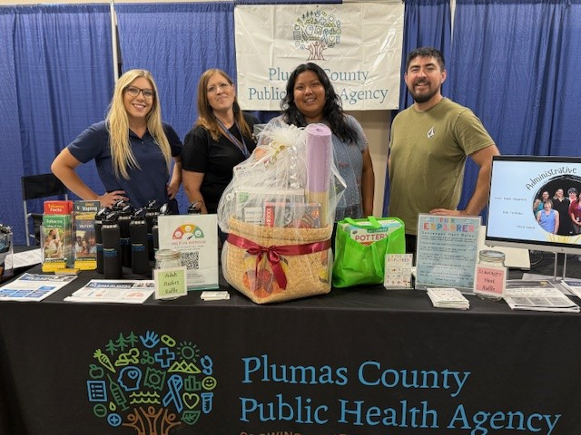

2024
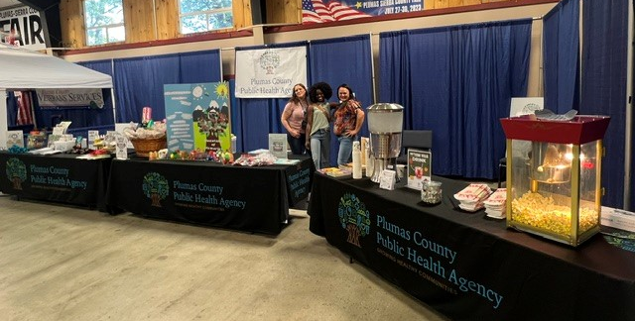
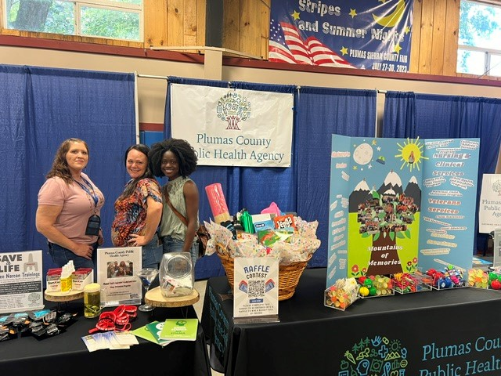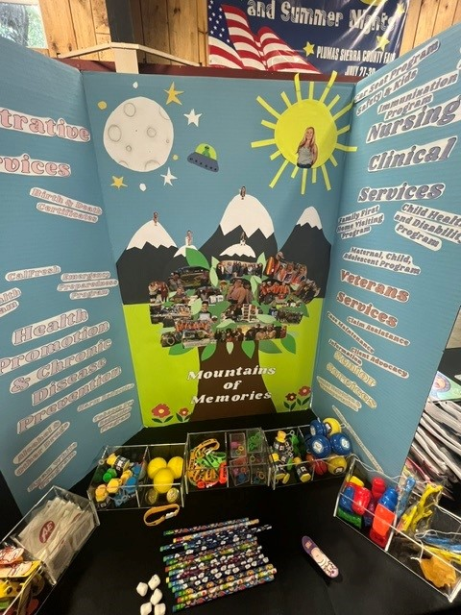

Appendix 1: Participant Written Comments by Theme
32 Surveys with no written responses

Praise on Fair Booth
*Note: Some comments were in multiple categories for the types of praises below.
Nonspecific Praise of overall execution of the fair booth
- Everyone and everything was great
- Thank you all so much. Everything and everyone is very helpful. I’ll be enjoying your popcorn now! Purse size hand sanitizers
- N/A it was great
- Nothing! Very good
- Thanks!
- Keep up the good work! Where is the harm reduction Van?
- Website with healthy events? All very good. Not needed. Keep doing it
- Keep doing the good work
- Thank you! Not at all (No need for improvement)
- Wonderful! Thank you (No need for improvement)
- Thank you for your participation!! :)
- Great
- Great Job!
- Nothing to improve
- n/a, Love it!
- Great to see the booth.
- Everything is pretty great
- Very nice
Praise on food/items
- Thank you for the popcorn. Maybe video
- Grateful for the naloxone and beverage testers
- Love the water for the kids & popcorn. Wonderful as is! Nice display
- Excellent already especially the popcorn
- Thank you for popcorn & toothbrush & information. Nothing (to improve)
- Thank you all so much. Everything and everyone is very helpful. I’ll be enjoying your popcorn now! Purse size hand sanitizers
- Thank you for the popcorn and cold water.
- Amazing popcorn. You can’t it’s the best
- Thank you for all samples
Praise on Fair Booth
- Keep up the great work! Everything came across very well organized and put together
- Keep it up! Looks great Already
- Info very helpful
- Great booth
- Looks great!
- Love the water for the kids & popcorn. Wonderful as is! Nice display
- Thank you for popcorn & toothbrush & information. Nothing (to improve)
- Great engagement and helpful literature
Praise on Staff
- Wonderful job- hard working staff – appreciate them!
- You were the best! Keep doing what you are doing
- Thank you for all you all do. No improvements at this time <3
- Thank you! You are all great
- Very friendly and awesome people. You’re doing an amazing job
- You’re great!
- Great engagement and helpful literature
- Thank you all so much. Everything and everyone is very helpful. I’ll be enjoying your popcorn now! Purse size hand sanitizers
- Friendly and helpful
- Stay the way you are!
- Everyone and everything was great
- Send these booth workers to the next one so it can be just as good
- Danielle needs a raise!!

Areas of Improvement
Merchandise/Food Request
- Chocolate
- Cute colorful plushies or such for kids
- Free chocolate
- Lemons or cucumbers in water. Pictures/graphics on the backdrop behind booth
- More popcorn
- More stuff in basket and more edible things in basket
- Purse size hand sanitizers
Improvements for Fair Booth
- Clipboard for survey
- Clipboard for the form
- None. Music?
- Working popcorn
Program Request
- Keep up the good work! Where is the harm reduction Van?

Information Sharing
- More publicity for the community to know you are on location
- Thank you for the popcorn. Maybe a video
- Website with healthy events? All very good. Not needed. Keep doing it (Put in program request)
- Have information about current health risks in the area (Put in program request)
- Lemons or cucumbers in water. Pictures/graphics on the backdrop behind booth
- Perhaps sign w/ explanation of services (bigger/clear)
- Have a good day. Come next year

No Improvement Needed
- Nothing
- Can’t think of anything
- No need
- Nothing I can note

Other
- Quincy [illegible]
- ?
- ?

